Gicumbi District
Kageyo Sector
Kageyo TSS

L3 Software Development

Basic Graphic Design

GENGD301

Academic Year:
2025-2026

Students Notes

Prepared by:
Joseph Marie ASHIMIRWE
On: 12th Sept 2025
At Kageyo TSS



MODULE: BASIC GRAPHIC DESIGN

Module Title: GENGD301

Learning Outcome 1: Edit Photos with Photoshop
Learning Outcome 2: Manipulate graphics with adobe illustrator.
Learning Outcome 3: Export File

L.O.1: EDIT PHOTOS WITH ADOBE PHOTOSHOP

: Introduction to Photoshop
Definition

Adobe Photoshop is a software application for image editing and photo retouching.
Or Adobe Photoshop is a software application used to create, edit, and manipulate digital images.
For Photographers: It's a photo editing tool. You can fix problems (like red-eye, blemishes, or bad lighting), adjust colors, and combine multiple photos into one perfect image.
For Designers: It's a graphic design tool. You can create layouts for posters, social media graphics, website mockups, and app interfaces by combining images, text, and shapes.
For Artists: It's a digital painting canvas. Using brushes, pencils, and other tools, you can create original artwork from scratch, just like painting on a physical canvas.

Who can use adobe Photoshop?

It is widely used for:

Image editing Retouching
Creating image compositions Website mockups
Adding affects.

Use of interface elements
PHOTOSHOP INTERFACE ELEMENT
- Menu bar
- Tool bar
- Document tab
- Options bar
- Layer panel
- History panel
- Zoom level
- Status bar

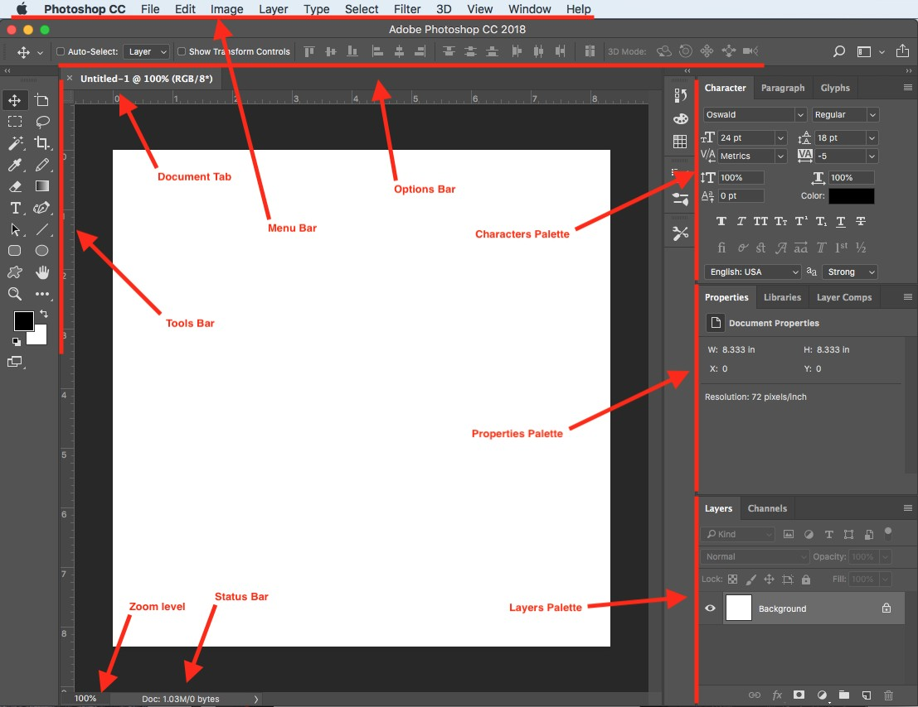

Photoshop selecting menu

Selecting menus is a fundamental part of accessing various commands and functions to manipulate and edit images.

- File Menu
- Edit Menu
- Image Menu
- Layer Menu
- Select Menu
- Filter Menu
- View Menu
- Window Menu
- Help Menu

Arranging panels

Panel refers to a movable, resizable, and customizable interface element that provides access to various tools, functions, and information.
Arranging panels in Adobe Photoshop is essential for customizing your workspace to fit your workflow and preferences.
You can arrange panels in Photoshop by:

- Undocking Panels
- Resizing Panels
- Grouping Panels
- Custom Workspaces
- Resetting Panels

Types of Panels:

- Tool Panels: include the Tools panel, the Color panel, and the Brushes panel.
- Adjustment Panels: Allow you to modify the appearance of your image, such as brightness, contrast, hue/saturation, and levels.
- Layer Panels: Allowing you to organize, edit, and manipulate individual elements within your image.
- Info and Properties Panels: These panels provide information about the selected elements, such as:
  - The color values of a pixel
  - The dimensions of a selection
  - and the properties of a layer.
- Navigation Panels: Help you zoom in and out of your image, as well as navigate within large documents.

Using ruler and setting guides
Rulers and guides help you maintain accuracy and consistency in your designs.

Use ruler
Select "Rulers" from the dropdown menu, or use the keyboard shortcut: Windows: Ctrl + R
Mac: Command + R
Layers are like transparent sheets stacked on top of each other, and you can edit or apply changes to individual layers without affecting the rest of the image.

Common keyboard shortcuts in Photoshop:

- General Shortcuts:

- Ctrl (Cmd on Mac) + N: New document.
- Ctrl (Cmd) + O: Open a file.
- Ctrl (Cmd) + S: Save a file.
- Ctrl (Cmd) + W: Close a document.
- Ctrl (Cmd) + Q: Quit Photoshop.
- Ctrl (Cmd) + Z: Undo the last action.
- Ctrl (Cmd) + Shift + Z: Redo the last action.
- Tool Shortcuts:

- V: Move Tool.
- M: Marquee Selection Tool.
- L: Lasso Tool.
- W: Magic Wand Tool.
- C: Crop Tool.
- I: Eyedropper Tool.
- B: Brush Tool.
- E: Eraser Tool.
- G: Gradient Tool.
- T: Text Tool.
- Y: History Brush Tool.
- J: Healing Brush Tool.
- S: Clone Stamp Tool.

View Shortcuts:

- Ctrl (Cmd) + +: Zoom in.
- Ctrl (Cmd) + -: Zoom out.
- Ctrl (Cmd) + 0: Fit to screen.
- F: Cycle through screen modes.
- Tab: Hide or show panels.
- F5: Show Brushes panel.

Layer Shortcuts:

- Ctrl (Cmd) + G: Group layers.
- Ctrl (Cmd) + Shift + N: Create a new layer.
- Ctrl (Cmd) + E: Merge selected layers.
- Ctrl (Cmd) + [: Move a layer down in the stacking order.
- **Ctrl (Cmd) + :] (right bracket): Move a layer up in the stacking order.
- Ctrl (Cmd) + Shift + [: Bring a layer to the front.
- **Ctrl (Cmd) + Shift + :] (right bracket): Send a layer to the back.

Selection Shortcuts:
- Ctrl (Cmd) + A: Select all.
- Ctrl (Cmd) + D: Deselect.
- Ctrl (Cmd) + Shift + I: Inverse selection.
- Ctrl (Cmd) + T: Free Transform.

Filter Shortcuts:

Ctrl (Cmd) + F: Apply the last-used filter.

Ctrl (Cmd) + Alt + F: Reapply the last-used filter with the same settings.

Navigation Shortcuts:

- Spacebar: Temporarily switch to the Hand Tool for navigation while dragging.
- Hold H + Click and Drag: Zoom in and out (up to zoom in, down to zoom out).

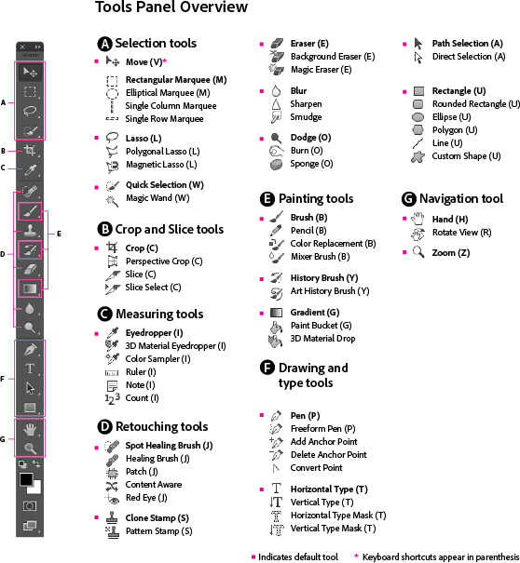

Common tools used in Photoshop

Selection Tools:
- Marquee Tool: Selects objects or areas with rectangular or elliptical shapes.
- Lasso Tool: Creates freehand selections.
- Magic Wand Tool: Selects areas with similar colors.
- Quick Selection Tool: Makes selections based on color and texture.
- Pen Tool: Creates precise paths and shapes.

6. Crop and Slice Tools: 6. Crop Tool: Cuts and resizes an image.
7. Slice Tool: Divides an image into sections for web use.

Retouching and Painting Tools: 8. Clone Stamp Tool: Duplicates parts of the image.
- Healing Brush Tool: Fixes imperfections by blending pixels.
- Spot Healing Brush Tool: Quickly removes blemishes.
- Brush Tool: Paints with various brushes and settings.
- Pencil Tool: Draws with a hard-edged pencil.
- Eraser Tool: Removes parts of an image.
- Dodge Tool: Lightens areas.
- Burn Tool: Darkens areas.
- Sponge Tool: Adjusts the saturation of an area.
- Smudge Tool: Smudges and blends pixels.

Text Tools: 18. Horizontal Type Tool: Adds horizontal text.
- Vertical Type Tool: Adds vertical text.
- Text Mask Tool: Creates text masks.
- Character and Paragraph Panels: Control text attributes and formatting.

Drawing and Shape Tools: 22. Line Tool: Draws straight lines.
- Rectangle Tool: Creates rectangular shapes.
- Rounded Rectangle Tool: Makes rectangles with rounded corners.
- Ellipse Tool: Draws ellipses and circles.
- Polygon Tool: Creates polygons with adjustable sides.
- Custom Shape Tool: Uses predefined custom shapes.

Color and Painting: 28. Eyedropper Tool: Samples colors from the image.
- Color Sampler Tool: Measures color values.
- Paint Bucket Tool: Fills an area with a selected color.
- Gradient Tool: Creates gradients for smooth color transitions.

Transform Tools: 32. Move Tool: Moves layers and selections.
- Artboard Tool: Creates and edits artboards.
- Hand Tool: Navigates around the image.
- Zoom Tool: Zooms in and out.
Layer Functions:
36. New Layer: Adds a new layer to the document.
  - Layer Mask: Hides or reveals parts of a layer.
  - Blending Modes: Control how layers interact with each other.
  - Layer Styles: Apply various effects to layers.
  - Group Layers: Organizes layers into groups.
  - Smart Objects: Embeds and edits external files non-destructively.
  - Adjustment Layers: Apply non-destructive adjustments to the image.

Filters:
43. Gaussian Blur: Applies a blur effect.
- Sharpen: Enhances image sharpness.
- Noise: Adds or reduces noise in the image.
- Liquify: Distorts and manipulates image elements.
- Lens Correction: Corrects lens distortion.
- Many more filter options: Provides various creative and corrective effects.

3D Tools:
49. 3D Material Drop Tool: Applies materials to 3D objects.
- 3D Rotate Tool: Rotates 3D objects.
- 3D Scale Tool: Scales 3D objects.
- 3D Pan Tool: Moves the camera in a 3D scene.

Image Adjustment Tools:
53. Levels: Adjusts image brightness, contrast, and color balance.
- Curves: Fine-tunes tonal and color adjustments.
- Brightness/Contrast: Modifies image brightness and contrast.
- Hue/Saturation: Changes hue and saturation.
- Color Balance: Adjusts the balance of colors.
- Vibrance: Increases the intensity of muted colors.

Navigation Tools:
59. Hand Tool: Drags the image when zoomed in.
60. Zoom Tool: Zooms in and out of the image.

Path Tools:
61. Path Selection Tool: Selects and manipulates vector paths.
62. Direct Selection Tool: Edits anchor points and handles.

Measurement Tools:
63. Ruler Tool: Measures distances and angles.
64. Count Tool: Counts items or marks in the image.

File Handling:
65. New: Creates a new document.
- Open: Opens an existing document.
- Save: Saves the current document.
- Save As: Saves the document with a new name or format.
- Export: Exports the document for web or other purposes.

View Options:
70. Grids and Guides: Shows grids and guides for alignment.
71. Rulers: Provides rulers for measurements.

Performing document pre-set

In Adobe Photoshop, a document preset is a predefined set of parameters and settings that determine the initial characteristics of a new document when you create it.
Document presets are designed to streamline the process of creating new projects by allowing you to quickly select a set of specifications that match a specific use case or output requirement.

Here are the key components of a document preset in Adobe Photoshop:

- Name: A descriptive name for your document preset, which can help you identify its purpose or intended use.
- Size: The dimensions of the document, specifying its width and height. This can be set in various units such as pixels, inches, or centimeters.
- Resolution: The number of pixels per inch (PPI) or dots per inch (DPI) in the document. This setting is crucial for determining the quality of images, especially for print projects.
- Color Mode: The color model used for the document. Common options include RGB (Red, Green, Blue) for digital and web projects, CMYK (Cyan, Magenta, Yellow, Black) for print projects, and Grayscale for black and white images.
- Color Profile: A color profile defines the color space and characteristics of the colors in your document. Different color profiles are suitable for different purposes, such as Adobe RGB for a broader color range in digital photography or sRGB for consistent colors on the web.
- Pixel Aspect Ratio: Relevant mainly for video projects, this setting ensures that pixels are displayed correctly in non-square pixel environments.

Import a photo
In Adobe Photoshop, you can import a photo in several ways, including using the:
- "Place" command
- Dragging and dropping the image into your workspace,
- Using the importation workflow.

Using "Place" Command:

Step 1: Open Photoshop

  - Open Adobe Photoshop on your computer.

Step 2: Create a New Document (Optional)

  - If you haven't already opened a document, you can create a new one by going to File > New. Or Ctrl + N

Step 3: Use "Place" Command:
  - Go to File > Open.
  - Navigate the location of your photo and select it.
  - Click "Open" to import the photo into your document.

Step 4: Adjust and Confirm:
  - Adjust the size and position of the placed photo as needed.
  - Press Enter or click the checkmark in the options bar to confirm.

By Dragging:

Step 1: Open Photoshop
  - Open Adobe Photoshop on your computer.

Step 2: Locate the Photo on Your Computer:
  - Navigate the location of the photo you want to import using your computer's file explorer.

Step 3: Drag and Drop:
  - Click on the photo and drag it into the Photoshop workspace.

Step 4: Adjust and Confirm:
  - Adjust the size and position of the photo as needed.
  - Release the mouse button to drop the photo into the document.

Using Importation Workflow:
Step 1: Open Photoshop
  - Open Adobe Photoshop on your computer.

Step 2: Import from Camera or Scanner (Optional):
  - If you are working with a camera or scanner, you can use the "Import" option in Photoshop.
  - Go to File > Import > [Your Device] and follow the on-screen instructions.

Step 3: Import Photos from Other Sources:
  - You can also import photos from other sources using the "Import" option.
  - Go to File > Import > [Select the appropriate option] and follow the prompts to import your photos.

Here are the basic steps for saving a project and some additional considerations: Save a Project:
- Save:
  - To save your project for the first time, or to save changes to an existing project, go to File > Save or use the keyboard shortcut Ctrl + S (Windows) or Cmd + S (Mac).
  - If you are saving for the first time, Photoshop will prompt you to choose a location and enter a filename. Choose a location on your computer and provide a name for your project.

Save As:
  - If you want to save a copy of your project with a new name, format, or in a different location, go to File > Save As or use the keyboard shortcut Shift + Ctrl + S (Windows) or Shift + Cmd + S (Mac).
  - This option allows you to create a duplicate of your project while preserving the original.

File Formats:

When saving your Photoshop project, consider the following file formats:

PSD (Photoshop Document):

  - This is the default and recommended format for saving your working project. It preserves layers, masks, and other editable elements.
  - PSD files retain the full range of editing capabilities in Photoshop.

Other Formats (JPG, PNG, TIFF, etc.):

  - If you need to export your project for sharing, printing, or use in other applications, you can use different file formats.
  - Go to File > Export or File > Save As and choose the desired format.

File Format | Best For... | Key Feature | Simple Analogy
PSD(Photoshop Document) | Saving your work-in-progress. | Saves everything: layers, effects, text (fully editable). | The original recipe with all ingredients separate.
JPEG (Joint Photographic Experts Group) | Sharing final photos online. | Small file size, but loses quality each time you save (lossy). | A baked cake – ready to eat, but you can't easily separate the eggs and flour.
PNG (Portable Network Graphics) | Web graphics with transparency. | High quality, supports transparent backgrounds (lossless). | A sticker – the image has a clear background and can be placed anywhere.
TIFF (Tagged Image File Format) | High-quality printing & archiving. | Extremely high quality, can also save layers (lossless). | A high-resolution archival photo print.
GIF (Graphics Interchange Format) | Simple web animations. | Supports basic animation and limited colors. | A flipbook – a simple, looping animation.
PDF (Portable Document Format) | Sending designs for print or review. | Preserves layout and quality; anyone can open it. | A digital brochure – looks the same on every device.
RAW (Raw Image Format) | Professional photo editing. | Unprocessed data from a camera sensor (maximum editing flexibility). | A photographic negative – it contains all the original data to work with.

Open Photoshop project

- Navigating documents

- Working with tabbed documents

- Arrange multiple opened documents

- Zooming techniques

Navigating Documents:
- Pan Tool: Press and hold the Spacebar to activate the Pan Tool. Click and drag to move around the document.
- Hand Tool: Located in the toolbar, you can click and drag with the Hand Tool to navigate within the document.
- Navigator Panel: Open the Navigator panel (Window > Navigator) to see a miniature view of your document. You can click and drag the red rectangle to navigate.

Working with Tabbed Documents:
In Photoshop, "Tabbed Documents" refers to the feature that allows you to have multiple project files open at once and easily switch between them by clicking on their respective tabs.
- Opening New Tabs: File > Open or simply drag and drop files into the Photoshop workspace. Each file opens in a new tab.
- Tab Bar: The top of the workspace shows tabs for each open document. Click on a tab to switch between documents.
- Close Tabs: Click the 'x' on a tab to close the document. Right-click on a tab for additional options.

Arrange Multiple Opened Documents:
- Tile All Vertically or Horizontally: Window > Arrange > Tile All Vertically/Horizontally to see multiple documents side by side.
- Cascade: Window > Arrange > Cascade to display open documents in a cascading order.

Zooming Techniques:
- Zoom Tool (Z): Click on the Zoom Tool in the toolbar, then click on the canvas to zoom in. Alt + click to zoom out.
- Zoom In/Out with Keyboard Shortcuts: Use Ctrl + "+" (Windows) or Command + "+" (Mac) to zoom in and Ctrl + "-" (Windows) or Command + "-" (Mac) to zoom out.
- Scrubby Zoom: Select the Zoom Tool and click-drag left or right to zoom in or out interactively.
- Navigator Panel: Use the percentage slider in the Navigator panel to adjust the zoom level.
- Fit to Screen: Double-click on the Zoom Tool or press Ctrl + 0 (Windows) or Command + 0 (Mac) to fit the entire image to the screen

: Remove Unwanted elements from the image
Tools used to remove unwanted elements from image in Adobe Photoshop:
- Crop tool: removes the part of an image surrounding the selection
- Marquee tool: Selects rectangular and square areas.
- Lasso tools: Allows creating freehand selections.
- Quick selection tool: Paint over the areas to be selected with a hard-edge Brush.
- Magic wand tool: Selects a consistently colored area.
- Eraser tool: Instead of painting on the pixels of your image, however, the Eraser deletes the unwanted pixels.
- Selection tools: Are what you will use to select portions of an image to edit.

Eight (8) Photoshop Selection Tools
- Rectangular Marquee Tool:
- Elliptical Marquee Tool:
- Lasso Tool.
- Polygonal Selection Tool.
- Magnetic Lasso Tool.
- Magic Wand Tool.
- Quick Selection Tool.
- Complex Selections: Adding, Subtracting, and Intersections.

Other ways used to remove unwanted elements from photos

- Converting a selection into a layer mask
- Filling selection with color
- Resizing image and adjusting resolution

Using crop tool

Difference ways of Cropping Image in Photoshop.
- Crop nondestructively
- Rotate crop area
- Straighten images
- Preserving the aspect ratio
- Cropping to perfect size

: Manage Layers
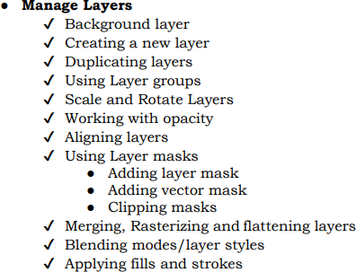
In Photoshop, a layer is a single level of an image that can be edited independently of other layers. Each layer can contain different elements such as text, shapes, images, or adjustments. Layers can be stacked on top of each other, and their order determines how the image is displayed.

Essential Layers:

- Background Layer: This is the bottom-most layer containing your original image data. It's usually locked to prevent accidental edits.
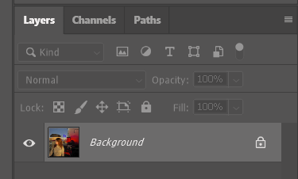

Background layer in Photoshop

Creating and Duplicating Layers:

- New Layer: Click the "New Layer" icon (looks like a sheet of paper) in the Layers panel to create a new blank layer above the selected layer.
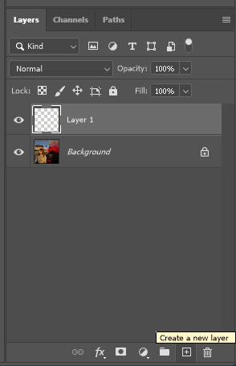
Create a New layer icon in Photoshop

New Layer icon in Photoshop

- Duplicate Layer: Right-click on a layer and choose "Duplicate Layer" to create an exact copy of that layer.
- Layer Style: is a non-destructive special effect, such as a drop shadow, outer glow, or stroke, that can be applied to a layer in the Layers panel. It is "linked" to the content of that layer, meaning the effect automatically updates as you edit the layer's content
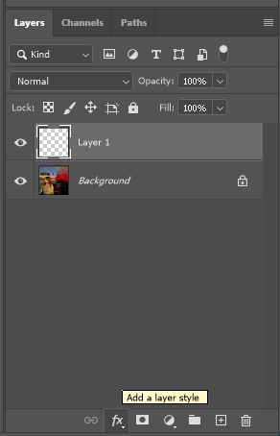
Add a layer style icon in Photoshop

- To link layers in Photoshop you'll be able to edit them together without having to select them every time. You select layers you want to link and click on this icon
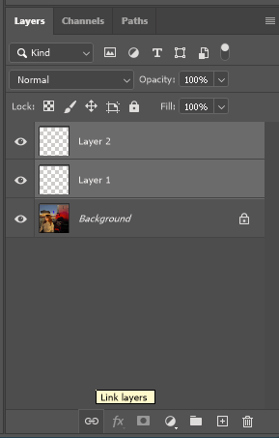
Link layer icon in Photoshop
- Delete Layer: To delete a layer you no longer need, just select the layer you want to delete and click on this icon below right
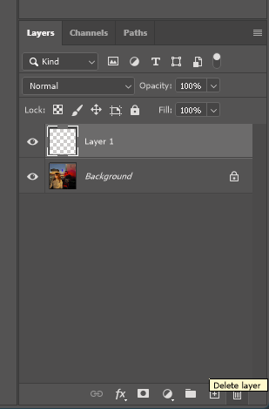
Delete icon in Photoshop

Organizing Layers:

- Layer Groups: Group related layers together using the "Create a New Group" icon (folder icon) to organize your workspace and manage complex compositions.
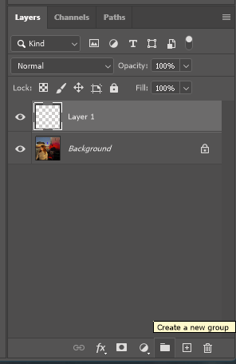

Create a New Group icon in Photoshop

- Scaling and Rotating Layers: Use the Transform tools (located in the toolbar or by pressing Ctrl+T/Cmd+T) to resize, rotate, or skew individual layers.

Controlling Layer Appearance:

- Opacity: Adjust the slider in the Layers panel to control the transparency of a layer, making it partially visible or invisible.
- Aligning Layers: Use the Align tools (found in the top menu bar) to precisely align multiple layers based on various criteria like edges or centers.

Layer Masks:
- Adding Layer Mask: Click the "Add Layer Mask" icon (looks like a circle with a diagonal line) to create a mask that hides parts of a layer, allowing you to edit selectively without affecting the original data.
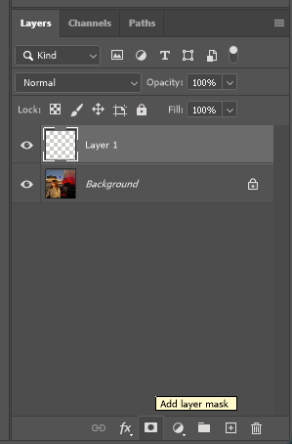
Add Layer Mask icon in Photoshop

- Vector Mask: Similar to a layer mask but uses editable vector paths for more precise control over masking shapes.
- Clipping Mask: Clip a layer to the layer below it by holding Alt (Option on Mac) and clicking between the two layers in the Layers panel.

: ADJUST AND RETOUCH PHOTO

Retouching a photo means making small adjustments or improvements to the image using digital editing software.
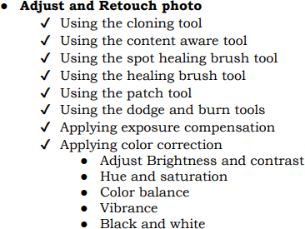

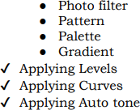

Common retouching techniques include:
- Color correction: Adjusting the colors in the image to improve the overall tone and balance of the photo.
- Brightness and contrast adjustments: Changing the brightness and contrast levels to make the image more visually appealing.
- Skin smoothing and blemish removal: Removing any imperfections from the skin, such as blemishes, scars, or wrinkles.
- Teeth whitening: Making teeth appear whiter and brighter.
- Eye brightening: Enhancing the color and brightness of the eyes.
- Background removal: Removing the background of the image and replacing it with a different background.

: Apply typography
- Using fonts and typefaces

Combining typefaces
- Using Size and measurements of types
Typography is the art and science of arranging and manipulating text to create visually appealing and readable compositions. It involves choosing the right typeface, font, size, spacing, and layout to convey a message effectively.

A typeface is the overall design of a set of characters, including their style, weight, and proportions. It's like the blueprint for a specific lettering style. Think of it as a family of related characters.
Examples: Helvetica, Times New Roman, Garamond, etc.

A font is a specific, digital realization of a typeface, with defined variations like weight, width, and style (e.g., Helvetica Bold Italic 12pt). It's like a single member of the typeface family, with its own unique characteristics.
Examples: Helvetica Bold Italic 12pt, Times New Roman Regular 14pt, Garamond Bold Condensed 10pt, etc.

Transform photo

Transforming a photo involves applying various adjustments to its size, shape, and orientation. Different transformation tools offer unique ways to modify images.

Transformation method:

- Using Scale
- Using Distort
- Using Skew
- Using Perspective
- Using Wrap
- Using Rotate
- Using Flip

Scale:
- Purpose: Resizes the entire photo proportionally, maintaining the original aspect ratio. Use it to enlarge or shrink the photo to fit a specific frame or composition.

Distort:
- Purpose: Stretches or squishes the photo unevenly in different directions, creating a warped or distorted effect. Useful for adding an artistic flair or achieving specific visual effects.

Skew:
- Purpose: Tilts the photo along a horizontal or vertical axis, introducing a slanted appearance. Often used for correcting tilted photos or creating interesting compositional angles.

Perspective:
- Purpose: Adds a 3D-like depth effect to the photo, manipulating the size and position of objects based on their distance from the "camera." Useful for simulating real-world perspective or creating depth in flat images.

Wrap:
- Purpose: Applies the photo texture onto a different shape or object, conforming it to the new shape's contours. Often used for creative effects like wrapping photos around text or objects.

Rotate:
- Purpose: Turns the photo around a fixed point, rotating it clockwise or counterclockwise. Use it to straighten tilted photos or adjust the composition for better viewing.

Flip:
- Purpose: Mirrors the photo horizontally or vertically, creating a reversed image. Can be used for artistic effects, creating reflections, or correcting accidentally flipped photos.

L.O.2: MANIPULATE GRAPHICS WITH ADOBE ILLUSTRATOR

Adobe Illustrator is a powerful vector graphics editor and design software developed and marketed by Adobe Inc. It is widely considered the industry-standard for creating scalable vector graphics, which are graphics made up of mathematical paths rather than pixels. This means that they can be resized infinitely without losing quality, making them ideal for a variety of applications, including:
- Logo and icon design: Logos and icons need to look sharp and clear at any size, from business cards to billboards.
- Illustration: Illustrator is a popular choice for creating illustrations, from simple line art to complex, detailed pieces
- Typography: Illustrator can be used to create high-quality typographic designs, such as logos, posters, and website headers.
- Pattern design: Illustrator is a great tool for creating seamless patterns, which can be used for fabric, wallpaper, and other applications.
- Web graphics: Illustrator can be used to create web graphics, such as
icons, buttons, and banners. The software's export options allow you to save your designs in a variety of formats that are compatible with the web.

Description of workspace

The Adobe Illustrator workspace is your personalized interface for creating vector graphics. It's designed to provide essential tools, panels, and menus within easy reach, enabling you to work efficiently and customize the layout to suit your preferences.

Use of Workspace elements

Key Workspace Elements:

    - Menus: Access commands and features categorized by function
(File, Edit, Object, etc.). Use keyboard shortcuts (Alt or Option key and corresponding menu letter) for faster access.

    - Panels: Offer specific controls and information (e.g., Layer panel, Color panel, Pathfinder panel). You can dock them (fixed position) or group them (movable collection).
    - Toolbar: Contains frequently used tools for drawing, shaping, editing, and
more. Customize by adding/removing tools (right-click) or using the Toolbar flyout menu.
    - Undo Command and History Panel: Undo/redo recent actions (Ctrl/Cmd + Z) or use the History panel to navigate a sequence of actions for granular control.
    - Preferences: Set global adjustments for behavior, performance, and more (Preferences
> General, Appearance, File Handling, etc.).

    - Workspaces: Different configurations of panels, menus, and toolbars tailored to specific tasks (e.g., Illustration, Painting, Typography).
    - Keyboard Shortcuts: Quickly execute commands directly without using menus or tools (learn from Edit > Keyboard Shortcuts or online resources).

Selecting Menus:

Users can access different functions and options by clicking on the menus at the top of the application window. For example, File, Edit, View, etc.

Setting Preferences:
    - Go to Edit > Preferences (or Illustrator > Preferences on Mac).
    - Explore different categories (General, Appearance, File Handling, etc.) to customize behavior.
    - Experiment with settings to find what works best for you.

Setting, Switching, and Saving Workspaces:

- Go to Window > Workspace.
- Choose a predefined workspace (Essentials, Painting, Typography, etc.).
- Click the New Workspace button to create a custom one.
- Arrange panels and tools as desired.
- Click the Save Workspace button and give it a name.
- Switch workspaces quickly using the Window > Workspace menu.

Types of Shortcuts:

    - Single-key shortcuts: These involve pressing a single key, such as V for Paste or P for Pen Tool.
    - Modifier key shortcuts: These involve pressing a key combination, often using the Ctrl (Windows) or Cmd (Mac) key along with another key. For example, Ctrl/Cmd + Z for Undo or Ctrl/Cmd + C for Copy.
    - Custom shortcuts: You can create your own custom shortcuts for frequently used commands.

Essential Shortcuts:

Here are some of the most common and useful keyboard shortcuts in Illustrator: Basic Navigation:
    - Spacebar: Temporary Hand tool for panning.
    - Ctrl (Windows) / Command (Mac) + Plus (+) or Minus (-): Zoom in or out.
    - Ctrl (Windows) / Command (Mac) + 0: Fit Artboard in Window.

Selection and Editing:

    - V: Selection Tool.
    - A: Direct Selection Tool.
    - Ctrl (Windows) / Command (Mac) + A: Select All.

Ctrl (Windows) / Command (Mac) + D: Deselect.
    - Ctrl (Windows) / Command (Mac) + X: Cut.

Ctrl (Windows) / Command (Mac) + C: Copy.
    - Ctrl (Windows) / Command (Mac) + V: Paste.
    - Ctrl (Windows) / Command (Mac) + F: Paste in Front.
    - Ctrl (Windows) / Command (Mac) + B: Paste in Back.

Object Transformation:

    - Ctrl (Windows) / Command (Mac) + T: Free Transform.
    - Ctrl (Windows) / Command (Mac) + 2: Lock or Unlock selected artwork.

Text:

    - T: Type Tool.
    - Ctrl (Windows) / Command (Mac) + Shift + > or <: Increase/Decrease Font Size.
    - Ctrl (Windows) / Command (Mac) + Shift + > or <: Increase/Decrease Tracking (letter- spacing).
    - Ctrl (Windows) / Command (Mac) + Shift + { or }: Increase/Decrease Kerning.

Layers:
    - Ctrl (Windows) / Command (Mac) + L: Open Layers panel.
    - Ctrl (Windows) / Command (Mac) + [ or ]: Send to Back or Bring to Front.

Miscellaneous:

    - Ctrl (Windows) / Command (Mac) + Z: Undo.

Ctrl (Windows) / Command (Mac) + Shift + Z: Redo.
    - Ctrl (Windows) / Command (Mac) + Shift + I: Image Trace (if applicable).

Ctrl (Windows) / Command (Mac) + S: Save.
    - Ctrl (Windows) / Command (Mac) + Alt + S: Save As.

Panels:
    - F12: Layers panel
    - F8: Brushes panel
    - F9: Swatches panel
    - F10: Gradient panel
    - F11: Pathfinder panel

Use Artboards

In Adobe Illustrator, an artboard is a rectangular canvas or workspace within the document where you create and arrange your illustrations, designs, or artwork. Each artboard represents a separate page or space for your graphic elements. Adobe Illustrator allows you to work with multiple artboards in a single document, making it easy to create complex illustrations or multiple variations of a design within the same file.
Creating a Project with Artboards:

- Open Illustrator: Launch Adobe Illustrator.
- New Document: Go to File > New (Ctrl/Cmd + N).
- Artboard Presets: In the New Document dialog, choose an Artboard preset from the Presets section (e.g., Web, Mobile, Print). This automatically sets the document size and artboard dimensions.
- Custom Artboard: If you prefer custom dimensions, deselect any Preset and adjust the Width and Height values manually.
- Multiple Artboards: Click More Options to access advanced settings. Under Artboards, select the number of artboards you want to create and their layout (Grid, Rows, or Columns).
- Create: Click Create to start your project with the specified artboards.

Customizing an Artboard:
- Select Artboard: Click on the artboard you want to modify.
- Artboard Tool: Select the Artboard tool from the Tools panel (second button from top).
- Resize & Reposition: Drag the artboard's edges to resize or click and drag it to a new location.
- Properties Panel: Adjust properties like width, height, bleed, and margins in the Properties panel (right of the workspace).
- Presets: Click the Presets dropdown in the Properties panel to quickly apply standard sizes.

Creating a Multi-Artboard Document:
- Follow steps 1-3 from "Creating a Project with Artboards": Choose an Artboard preset or set custom dimensions.
- Artboards Menu: Go to Window > Artboards.
- Create Artboards: Click the "Create Artboards" button in the Artboards panel.
- Rows & Columns: Enter the desired number of rows and columns in the corresponding boxes.
- Spacing: Adjust the spacing between artboards in the Gutters box.
- Click Create: The specified number of artboards will be automatically created in your document.

Arranging the Artboards Panel:
- Show Panel: Go to Window > Artboards to open the Artboards panel.
- Sorting: Click the column headers (Name, X, Y, W, H) to sort artboards by different criteria.
- Visibility: Click the eye icon next to an artboard name to hide or show it in the document.
- Grouping: Select multiple artboards and click the Group button to organize them.
- Renaming: Double-click an artboard name and type a new one.

Modifying and Saving a Project:

- Work on your artboards: Design and edit your content within each artboard.
- Save: Go to File > Save (Ctrl/Cmd + S) to save your project.
- Save As: If you want a different version, go to File > Save As (Shift + Ctrl/Cmd + S) to create a copy with a new name.
- Exporting: For specific outputs, use File > Export to choose various formats

(PNG, SVG, PDF, etc.).

Use layers

A layer in Adobe Illustrator is a virtual, transparent plane within a document that contains and organizes specific elements or objects. Each layer can hold a distinct set of content, such as shapes, text, or images. Layers provide control over the visibility, stacking order, and attributes of the objects they contain, allowing users to efficiently work on and manage intricate illustrations and designs.

Using the Layer Panel:
- Accessing the Panel: Go to Window > Layers (or simply click the Layers icon next to the Swatches panel).
- Understanding the Structure: Each layer represents a stacked sheet of content. Layers higher in the panel appear on top of those below.
- Layer Controls: Each layer entry has icons for visibility (eye), lock (padlock), and link (chain). Use these to control layer visibility, editing restrictions, and linking.
- Selection and Targeting: Click a layer name to select its content. Click the target icon to target only that layer for further edits.

Creating, Editing Layers and Sublayers:
- Create New Layer: Click the "Create New Layer" button at the bottom of the panel.
- Duplicate Layer: Right-click a layer and choose "Duplicate."
- Rename Layer: Double-click a layer name and type a new one.
- Delete Layer: Right-click a layer and choose "Delete."
- Sublayers: Drag a layer onto another to create a sublayer. Use sublayers to organize complex elements within a layer.
- Grouping Layers: Select multiple layers and click the "Group" button to treat them as one unit.

Moving Layers:
- Drag & Drop: Click and drag a layer up or down in the panel to reposition it.
- Cut & Paste: Right-click a layer and choose "Cut" or "Copy," then right-click in the desired location and choose "Paste Before" or "Paste After."

Merging Layers:

- Select Layers: Choose the layers you want to merge by holding Shift or Ctrl/Cmd while clicking.
- Merge: Right-click on the selected layers and choose "Merge Layers."

Arranging Layers:

- Lock/Unlock Layers: Click the padlock icon to prevent accidental edits.
- Hide/Show Layers: Click the eye icon to hide or show layers without deleting them.
- Opacity: Adjust the layer's opacity slider to control its transparency.
- Blending Modes: Change the blending mode (Normal, Multiply, Screen, etc.) to create special effects between layers.

: Create vector paths

A vector path in Adobe Illustrator, and in broader graphics design, is an outline or shape defined by mathematical formulas instead of individual pixels.

Path Types:
    - Lines and Shapes: Use tools like the Line Tool, Rectangle Tool, Ellipse Tool, Polygon Tool, and Star Tool to create basic geometric shapes and straight lines. These have fixed properties and lack control handles.
    - Freeform Paths: Employ the Pen Tool for drawing custom freeform paths with curves and corners. This offers the most flexibility and control over the path's shape.
    - Combined Paths: Use Pathfinder tools like Unite, Combine, Subtract, and Intersect to combine, manipulate, and merge existing paths to create complex shapes.

Using the Pen Tool:

- Click and Drag: Click to create anchor points. Drag to create curved segments between them.
- Control Handles: Click and drag control handles to adjust the curve direction and shape.

- Toggle Curve Types: Hold Alt/Option while clicking an anchor point to switch between smooth and sharp curves.
- Pen Tool Modes: Explore modes like Add Anchor Point, Delete Anchor Point, and Convert Anchor Point for precise editing.

Using Control Handles:

- Direction: Drag handles away from the path to create wider curves, drag towards the path for tighter curves.
- Smoothness: Click-drag handles while holding Shift to create straight lines instead of curves.
- Symmetry: Hold Ctrl/Cmdr. while dragging handles to constrain movement horizontally or vertically for symmetrical curves.

Using the Selection Tool:
- Select Entire Path: Click the path itself.
- Select Individual Segments: Hold Shift while clicking segments to select multiple ones.
- Reshape Path: Drag selected segments or anchor points to modify the path.

Using the Scale Tool:
- Select Path: Choose the Selection Tool and click the path.
- Click & Drag: Hold Shift while dragging a corner handle to scale proportionally.
- Uneven Scaling: Drag corner handles individually without Shift for non-uniform scaling.

Using the Rotate Tool:
- Select Path: Choose the Selection Tool and click the path.
- Click & Drag: Click outside the path and drag to rotate it around its center.
- Rotation Center: Click near a specific point on the path to set that as the rotation center.

Using the Direct Selection Tool:
- Precise Editing: Select individual anchor points or handles for granular control.
- Adjust Curve Shape: Modify individual control handles directly for detailed curve adjustments.
- Convert Anchor Points: Right-click and choose "Convert Anchor Point" to change between smooth and sharp curves.

: Design shapes

- A shape is a two- dimensional object defined by points and lines that come together to create a closed area.
Basic shapes: Squares, circles, triangles, rectangles, polygons, stars

More complex shapes: Cones, cylinders, spheres, pyramids, prisms Drawing basic shapes

Draw basic shapes

- Lines

Curves
- Spirals

Rectangles
- Ellipses

Polygons
- Stars

Using Pencil tool for freehand drawing
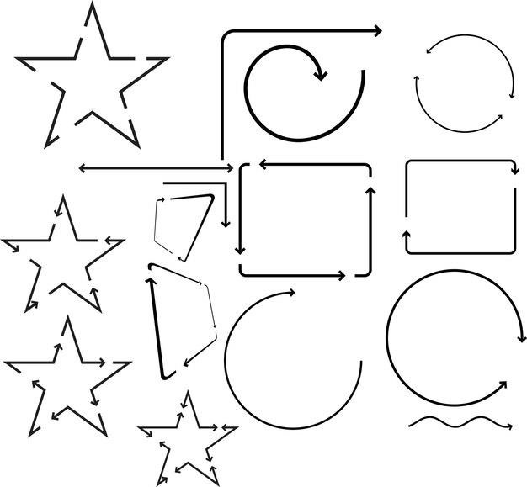

Modifying shapes and paths
- Drawing modes
- Creating compound paths and shapes
- Using the Brush tool
- Working with the Pathfinder panel
- Using the Eraser tool
- Using the anchor points
- Using the Shape Builder tool

Transforming objects
- Scaling objects
- Rotating objects
- Reflecting objects
- Distorting objects
- Moving and duplicating objects

Manipulating fills and strokes
A fill refers to the interior color or pattern applied to the entire enclosed area of a shape or path. While A stroke is a line or border applied to the outline of a shape or path.
- Adding color fill
- Creating and using gradient fills
- Adding strokes to objects
Adding Color Fills:
  - Fill Panel: Select your object and access the Fill panel (Window > Fill).
  - Solid Colors: Choose a color from the Color panel or the built-in library. Click the Fill panel swatch to apply.
  - Using Patterns: Select a pattern from the Swatches panel or create your own by clicking the "New Swatch" button.
  - Transparency: Adjust the Opacity slider in the Fill panel to create transparent fills, allowing underlying elements to show through.

Creating and Using Gradient Fills:

  - Gradient Panel: Open the Gradient panel (Window > Gradient).
  - Linear Gradient: Click and drag between two color stops to create a linear gradient (horizontal or vertical).
  - Radial Gradient: Click and drag away from a central point to create a radial gradient (outward or inward).
  - Multiple Stops: Add more color stops by clicking below the gradient bar to create intricate color transitions.
  - Editing Stops: Adjust stop positions and colors directly on the gradient bar for precise control.

Adding Strokes to Objects:

  - Stroke Panel: Select your object and access the Stroke panel (Window > Stroke).
  - Solid Colors: Choose a color from the Color panel or the built-in library. Click the Stroke panel swatch to apply.
  - Stroke Weight: Adjust the Weight slider to control the stroke thickness. Explore pixel values or points for precise size control.
  - Dashed Strokes: Enable the "Dashed Line" checkbox and adjust dash and gap values to create custom dotted or dashed lines.
  - Stroke Align: Choose between "Align Stroke to Inside," "Align Stroke to Outside," or "Center Stroke" to define where the stroke sits relative to the path.

Text Tools:

  - Selecting: Press "T" or click the Text tool icon on the toolbar. Choose between Horizontal Type Tool (default) and Vertical Type Tool.
  - Adding Text: Click on the canvas and type your desired text.
  - Formatting: Use the options bar above the canvas to change font, size, color, alignment, etc.
  - Transforming: Press "Ctrl/Cmd + T" to edit text size, rotation, and distortion.
  - Character Styles: Access the panel (Window > Character) for detailed text formatting like caps, underline, etc.
  - Type on Path: Click the pen icon next to the "T" icon and draw a path. Click the text area and type along the path.

Swatches Panel:

  - Stores and manages pre-selected colors for quick access.
  - Click the "Swatches" tab on the right panel.
  - Double-click a swatch to edit its color.
  - Click the "+" button to create new swatches.

Color Panel:
  - Provides various color models and tools for precise color selection.
  - Click the "Color" tab next to "Swatches."
  - Choose a color model (e.g., HSB, RGB).
  - Use sliders or enter values to select a specific color.

Picking Color from Image:
  - Click the "Eyedropper" tool in the toolbar.
  - Click on a color in your image to sample it.
  - The selected color will appear in the foreground or background color swatch.

Opacity:
  - Controls the transparency of a layer or selection.
  - Use the slider in the Layers panel (0% = fully transparent, 100% = fully opaque).

Flowing Text Around Objects:
  - Select the text layer.
  - Go to "Window" > "Paragraph."
  - Choose "Wrap around object style" and adjust settings.

Type on Path:
  - As mentioned above, convert a path into a type container using the pen tool.
  - Type your text along the path and adjust its direction and style.

Converting Text to Path:
  - Select the text layer.
  - Right-click and choose "Convert to Shape" > "Path."
  - The text becomes a vector path editable with the Pen tool.

: Description of brand identity

- Brand
- Brand identity
- Brand icon
- Brand identity guidelines
- Logo

Brand:
A brand is a full concept that represents a company, product, service, or organization. It encompasses the entire customer experience, including visual elements, messaging, values, and the emotional connection people have with the entity.

Brand Identity:
Brand identity is the visual and sensory representation of a brand. It includes the design elements, such as logos, color schemes, typography, imagery, and other visual assets that create a consistent and recognizable look and feel for the brand.

Brand Icon:
A brand icon is a simplified and often stylized graphical representation that serves as a recognizable symbol of a brand.

Brand Identity Guidelines:

Brand identity guidelines, also known as brand style guides, are documents that provide detailed instructions on how to use and apply the various elements of a brand identity consistently.

Logo:

A logo is a visual representation of a brand and is a key element of its overall identity. Logos are designed to be unique, memorable, and easily recognizable.

Types of logo

  - Logotype (or Wordmark):

This type of logo uses the company name itself as the logo design, often using a stylized or unique typography.


FedEx logo
Example: FedEx
  - Letter mark (or Monogram): This logo uses the initials of the company name to create a recognizable symbol.

NASA logo

Example: NASA (National Aeronautics and Space Administration)

  - Pictorial Mark (or Brand Mark): This logo uses an icon or symbol to represent the company.


Apple logo
Example: Apple

  - Abstract Mark: This logo uses an abstract shape or symbol that doesn't directly represent the company name or product, but evokes a certain feeling or idea.


Pepsi logo
Example: Pepsi

  - Mascot Logo: This logo uses an illustrated character as the brand mascot.


Colonel Sanders KFC logo

Example: Colonel Sanders (KFC)

  - Combination Mark: This logo combines elements of wordmark and pictorial mark, showcasing both the company name and an icon.


Lacoste logo

Example: Lacoste (the crocodile icon with the company name)

  - Emblem: This logo incorporates a symbol or icon within a crest or shield-like design, often used by institutions or organizations.


Harvard University logo

Example: Harvard University

: Design infographics

An infographic, short for "information graphic," is a visual representation of information, data, or knowledge. Types of infographics:
- Icon
- Logo
- Web banners
- Flyer

Icon: A small, simplified graphic representing a concept, object, or action. Icons are used in user interfaces, websites, apps, and other digital contexts to communicate information quickly and intuitively.
Logo: A unique visual symbol or design that represents a brand, company, or organization.

Web banner: A rectangular graphic advertisement displayed on a website, typically used to attract attention, promote a product or service, and direct users to a landing page.
Flyer: A single sheet of paper printed with information or advertising, often used for marketing purposes. Flyers can be used to announce events, promote products, raise awareness, or distribute information.

Description of design principals

    - Balance:

      - Balance refers to the distribution of visual weight in a design. There are three types of balance: symmetrical, asymmetrical, and radial.

Contrast:

      - Contrast involves juxtaposing different elements to create visual interest and highlight important information.

Unity:

      - Unity, or harmony, ensures that all elements in a design work together cohesively.

Emphasis:

      - Emphasis involves giving prominence to specific elements within a design to capture attention and communicate hierarchy.

Rhythm:

      - Rhythm establishes a sense of movement and flow in a design by creating visual patterns or sequences.

Proportion and Scale:

      - Proportion and scale involve the relationships between different elements' sizes and how they relate to one another.

Hierarchy:

      - Hierarchy establishes an order of importance within a design, guiding the viewer's eye through a structured visual arrangement.

Typography:

      - Typography principles guide the effective use of fonts, sizes, spacing, and alignment to enhance readability and convey the desired tone.

Color Theory:

      - Color theory explores the interaction of colors and their psychological impact. Understanding color harmonies, contrasts, and associations helps designers create visually appealing and meaningful color schemes.

White Space (Negative Space):

      - White space, or negative space, is the unmarked area in a design. Proper use of white space enhances readability, reduces visual clutter, and provides balance to the overall composition.

Create a brand identity guideline

Features/Aspects of your brand identity guidelines:

- Analyze brand Mood
- Determine typography
- Determine color patterns
- Determine spacing
- Determine shadows and line styles
- Specify logo usage

Analyze Brand Mood:

  - Define the emotions and feelings you want your brand to evoke (e.g., trustworthy, playful, innovative).
  - Use mood boards and adjectives to visually represent the desired brand identity.

Determine Typography:

  - Choose a primary and secondary font family that aligns with your brand mood and target audience.
  - Define specific fonts for headings, body text, logos, and other elements.

  - Specify font size, weight, and spacing guidelines.

Determine Color Patterns:

  - Choose a primary and secondary color palette that reflects your brand values and resonates with your target audience.
  - Define additional accent colors and their usage guidelines.

  - Consider color accessibility for diverse audiences.

Determine Spacing:

  - Establish minimum and maximum spacing between elements for a consistent and organized look.
  - Define margins, padding, and line spacing for different media (print, digital).

Determine Shadows and Line Styles:

  - Decide on the use of shadows, outlines, and other visual effects for logos, icons, and other elements.
  - Ensure consistency in applying these styles across your brand materials.

Specify Logo Usage:

  - Provide clear instructions on acceptable and unacceptable uses of your logo (e.g., minimum size, color variations, prohibited modifications).
  - Include examples of proper and improper logo usage.

Create Icons

  - Sketching ideas
  - Using basic shapes to build icon symbols
  - Apply color association
  - Adding shine, gloss, shadow, texture, beveled edges, 3D, and transparency effects

Create Logo

  - Using Design considerations
    - Brand Identity: Clearly define your brand's personality, values, and target audience. Your logo should visually represent these core aspects.
    - Functionality: The logo should be recognizable and work well in various sizes and applications, from digital icons to printed materials.
    - Simplicity: A simple, memorable logo is more impactful and easier to reproduce.
  - Selecting Types
  - Using basic shapes to build a logo symbols
  - Selecting Logo motifs
    - Motifs are symbolic elements: These can be animals, objects, or abstract shapes that hold a deeper meaning related to your brand.
  - Tracing image
  - Using typography
    - Font selection is crucial
    - Consider using a combination of fonts
  - Applying effects (gradients, drop shadows, or rounded corners to your logo for visual interest.)
  - Applying vectors
Scalability is key: Create your logo in a vector graphics program like Adobe Illustrator. Vector logos can be scaled to any size without losing quality, making them ideal for various uses.
  - Using black and white alternations

Create web banner

a guide to consider when creating web banners

- Design considerations
- Applying Web based types
- Sketch blueprints
- Selecting Formats
- Selecting Sizes

Design Considerations:

  - Target audience: Who are you trying to reach with your banner? Tailor the design, message, and visuals to resonate with their interests.
  - Brand Identity: Ensure your banner reflects your brand's overall look and feel, including colors, fonts, and messaging.
  - Call to action (CTA): What do you want viewers to do after seeing your banner? Include a clear and concise CTA button.
  - Focus on benefits: Highlight the key benefits your product or service offers.

  - Simplicity is key: Keep the design clean and uncluttered for maximum impact.

Web-Based Fonts:

  - Web-safe fonts: Use fonts that are universally supported by most web browsers to avoid display issues. Common web-safe fonts include Arial, Verdana, and Times New Roman.
  - Consider custom fonts: For a unique look, you can explore using custom fonts. However, ensure they are web-compatible and load quickly.

Sketching Blueprints:

  - Low-fidelity sketches: Before diving into digital tools, sketch out some layout ideas on paper. This helps brainstorm ideas and define the overall structure of your banner.
  - Refine your concept: Use your sketches to refine your concept and determine the placement of visuals, text, and the CTA button.

Selecting Formats:

  - Common banner formats: Popular web banner formats include:

Medium Rectangle (300x250 pixels)

    - Leaderboard (728x90 pixels)

Large Rectangle (336x280 pixels)

    - Square (250x250 pixels)

  - Choose based on ad placement: The best format depends on the specific ad space you're targeting on a website.

Selecting Sizes:

  - File size optimization: Keep your banner file size as small as possible to ensure fast loading times. This is crucial as large files can slow down webpage loading, impacting user experience.
  - Common file formats: Popular web banner formats include JPG, PNG, and GIF.

    - JPG: Good for photos and images with a lot of color variations.

    - PNG: Supports transparency and works well for graphics with text or logos.

    - GIF: Can be used for simple animations but can result in larger file sizes.

Create Flyer

- Selecting Types
- Selecting Elements
- Applying graphics and typography
- Setting Standard sizes
Flyers are a versatile marketing tool used to promote events, products, services, or announcements. Here's a breakdown of the steps you mentioned to guide you through the flyer design process:

Selecting Flyer Types:

There are various flyer types depending on your purpose:

  - Promotional flyers: Advertise products, services, or upcoming events.

  - Informational flyers: Share educational content or raise awareness about a cause.

  - Event flyers: Promote upcoming events, gatherings, or workshops.

  - Announcement flyers: Make announcements about new business hours, location changes, or special offers.

Selecting Flyer Elements:

  - Headline: A clear and concise headline that grabs attention and conveys your message.

  - Subheading (optional): Provides additional details about the headline.

  - Body copy: Informative text that elaborates on your message and highlights key points.

  - Call to action (CTA): Tell viewers what you want them to do after seeing the flyer (e.g., visit a website, attend an event, call a number).
  - Visuals: Images, illustrations, or photos that visually represent your message and enhance the flyer's appeal.
  - Contact information: Include your website address, phone number, email address, or social media handles.

Applying Graphics and Typography:

  - High-quality visuals: Use high-resolution images or illustrations that are relevant to your message and visually appealing.
  - Choose appropriate fonts: Select fonts that are easy to read and complement your brand identity (if applicable).
  - Maintain hierarchy: Use different font sizes and weights to create a visual hierarchy, guiding the viewer's eye through the information.
  - Color psychology: Consider color psychology when choosing colors for your flyer. Colors can evoke emotions and influence perception.

Setting Standard Sizes:

  - Common flyer sizes: Popular flyer sizes include:

    - US Letter (8.5" x 11") - A versatile size suitable for various purposes.

    - A4 (210mm x 297mm) - Standard size in many parts of the world.

    - Half-page (8.5" x 5.5") - Good for targeted promotions or announcements.

    - Square flyers (various sizes) - Can be eye-catching for creative uses.

  - Choose based on content and distribution: The best size depends on the amount of information you need to convey and how you plan to distribute the flyer (e.g., mailboxes, bulletin boards, hand-outs).

Apply effects by combining types

Some ways to achieve this by merging effect categories:

Blending Utility with Visual Appeal:

  - Combine shadows and textures: Add a subtle texture to a drop shadow to create a more realistic or weathered look.
  - Gradients with inner glows: Use a gradient that transitions from a dark color to a lighter color on the inside of an object, along with an inner glow to create a soft, illuminated effect.

Creating Depth with Dimension:
  - Outer glow with bevels: Combine an outer glow with a bevel effect to create a 3D, almost chiseled look for buttons or icons.
  - Inner shadow with embossing: Use an inner shadow to create depth within an object, and complement it with an emboss effect to push out certain areas, mimicking a sculpted appearance.

Artistic Expression through Playful Techniques:

  - Halftone patterns with distortions: Overlay a halftone pattern (creates a printed comic book effect) on an image and then apply a slight distortion effect like a wave or bulge for a unique, artistic look.
  - Pixilation with motion blur: Apply a pixelation effect to an image, then add a subtle motion blur to create a sense of movement or speed.

Learning outcome 3: Export file

  - : Selection of file format

A file format is a standardized way of organizing and storing data in a computer file. It defines the structure and encoding of data within the file, including how the data is represented, organized, and accessed.

Types of File Formats:

  - Document Files: Designed for storing and sharing textual content. Popular formats include:
    - .docx (Microsoft Word): The industry standard for editable word processing documents with formatting options.
    - .pdf (Portable Document Format): Universal format for preserving document layout and formatting across different devices and platforms.
    - .txt (Text File): Simple format containing plain text without formatting, ideal for basic notes or code.
  - Image Files: Store digital pictures and graphics. Common formats include:

    - .jpg (JPEG - Joint Photographic Experts Group): Widely used for photos due to its compressed file size, but compression can lead to some loss of image quality.
    - .png (Portable Network Graphic): Supports lossless compression, ideal for graphics with sharp lines and text, or images requiring transparency (like logos).
    - .gif (Graphics Interchange Format): Can display simple animations and supports a limited color palette, often used for web graphics or memes.
    - .bmp (Bitmap Image): Uncompressed format resulting in large file sizes, but maintains high image quality. Often used for storing original photos or digital paintings.
  - Audio Files: Contain recorded sounds and music. Popular formats include:

    - .mp3 (MPEG-1 Audio Layer III): Highly compressed format for storing music, making it suitable for digital downloads and streaming.
    - .wav (Waveform Audio Format): Uncompressed format preserving high audio quality, often used for professional audio editing or storing original recordings.
    - .flac (Free Lossless Audio Codec): Compressed format that maintains the original audio quality like WAV files, but with smaller file sizes.
  - Video Files: Store moving images and sound for video playback. Common formats include:
    - .mp4 (MPEG-4 Part 14): Versatile format supporting high-quality video and audio, commonly used for online videos and social media sharing.
    - .avi (Audio Video Interleaved): Older format for storing video on Windows systems.
    - .mov (Apple QuickTime Movie): Developed by Apple, commonly used for storing and editing videos on Mac systems.

: Set image quality

Image quality refers to how well an image depicts the original scene or object it represents.

key aspects that contribute to image quality:

- Resolution
- Color accuracy
- Noise
- Artifacts
- Sharpness
- Contrast
- Dynamic range

Identification of Image optimization tools and programs

Image optimization is the process of modifying digital images to reduce their file size without losing a significant amount of quality.

This is important for several reasons:

  - Faster loading times: Smaller image files load quicker on webpages, improving user experience and website performance. Search engines also tend to favor faster-loading websites in their rankings.
  - Reduced bandwidth usage: Smaller files use less data to download, which can be beneficial for users on limited data plans or in areas with slow internet connections. This can also save costs for website owners with pay-as-you-go bandwidth plans.
  - Improved mobile experience: Mobile devices often have slower connections and limited storage space. Optimized images ensure a smooth browsing experience on smartphones and tablets.

There are two main types of image optimization tools:

- Online image optimization tools: These tools are web-based and allow you to compress images directly from your web browser. They are typically free to use for a limited number of images per month, but they may have paid plans for higher usage
- Desktop image optimization software: These tools are downloaded and installed on your computer. They offer more features than online tools, such as batch processing and the ability to compress images to specific file sizes. They may be free or paid.

some popular image optimization tools and programs:

- Online tools:

  - TinyPNG: A popular free online tool that specializes in compressing PNG images.

  - Optimizilla: Another free online tool that can compress JPEG and PNG images.

  - Kraken.io: A free and paid online tool that offers a variety of image optimization options.

Desktop software:

  - Adobe Photoshop: A powerful image editing software that includes image optimization features.
  - ShortPixel: A free and paid desktop tool that specializes in image compression.

  - ImageOptim: A free and open-source image optimization tool for Mac.

Compression

Compression is the process of reducing the size of a digital file, in this case, an image. There are

two main types of compression used for images: lossy and lossless. Lossy Compression:
- Goal: Achieve the highest possible file size reduction.
- Method: Permanently discards some image data during compression. This data is typically chosen to be less noticeable to the human eye, such as subtle color variations or minor details in textures.
- Impact on Quality: Can introduce artifacts (visible blockiness or blurring) into the image, especially with high compression ratios. The more you compress a lossy image, the worse the quality becomes.
- Use Cases: Ideal for situations where reducing file size is a top priority, such as web images, social media posts, or emails. The slight quality loss is often acceptable for these purposes.

Lossless Compression:

- Goal: Reduce file size without any loss of image quality.

- Method: Identifies and removes redundant data from the image file without affecting the actual image information. This can include things like unused color palettes or inefficient storage of pixel data.
- Impact on Quality: Maintains the original image quality pixel-for-pixel.

- Use Cases: Preferred for situations where preserving image quality is crucial, such as archiving original photos, storing important documents, or creating high-resolution graphics.

Resizing an image to scale

Resizing an image to scale refers to the process of adjusting the image dimensions while maintaining the original proportions (aspect ratio). This ensures the image doesn't become distorted or stretched.

: Export artwork Photoshop:

- Paths to Illustrator: Exporting paths from Photoshop to Illustrator allows you to maintain vector quality for further editing or scaling in Illustrator.
- Zoomify: Zoomify allows you to export large images for web viewing with zoom functionality, enabling users to zoom in and out of high-resolution images.
- Save for Web: This option is used to optimize images for web use by reducing file size while maintaining acceptable quality. It's commonly used for exporting JPEGs, PNGs, and GIFs.

Illustrator:

- Export for Screens: This feature in Illustrator allows you to export multiple artboards or assets for various screen sizes and resolutions in different formats.
- Export As: Provides options for exporting artwork in various formats such as JPEG, PNG, SVG, etc., with customizable settings.
- Save for Web: Similar to Photoshop, this option in Illustrator allows you to optimize images for web use by reducing file size while maintaining quality.

END

